**GROUP 5.9**

**Name - Rushikesh Nalla**

**ID - 201401106**

**Name - Omkar Damle**

**ID - 201401114**

**Class Model**

**CENTRALISED SCHOLARSHIP MANAGEMENT SYSTEM**

**Class Diagram :**

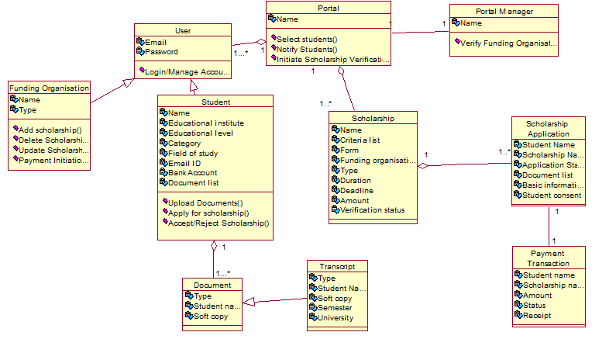

**FINAL CLASSES**

|  |  |  |
| --- | --- | --- |
| **Classes** | **Attributes** | **Methods** |
| User | Email, Password | Login/Manage Account |
| Student | Student Name, University, Document list, Education Level, Field of Study, Email, Bank account, Category. | Upload Documents, Accept/Reject Scholarship, Apply For Scholarship |
| Scholarship | Scholarship Name, Criteria, Form, Funding Organization, Scholarship Type, Scholarship Duration, Scholarship Deadline, Scholarship Amount, Verification status |  |
| Funding organisation | Funding Organization Name, Funding Organization Type | Add/Update/Delete Scholarship, Payment Initiation |
| Portal Manager | Name | Verify Funding Organization |
| Portal | Name | Select/Notify Students, Initiate Scholarship Verification |
| Scholarship Application | Student Name, Scholarship Name, Application status, Documents,basic information, student consent(if accepted) |  |
| Payment transaction | Student Name, Scholarship Name, Amount, status, receipt |  |
| Document | Type, student name, soft copy |  |
| Transcript | student name, type, semester number, university, soft copy. |  |